

Touring NYC’s Terraces: An Outdoor Space for Every Taste
June 22, 2010 01:26 PM
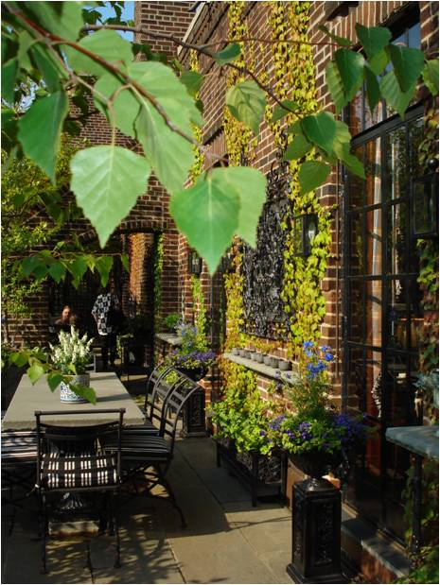
UnBeige HQ is home to several excellent chairs and enough design books to make industrial shelving shudder, but our outdoor space is limited to a rickety fire escape of questionable escape-worthiness. Thus our fascination with the rarified species known as the Manhattan terrace.
We dispatched writer Nancy Lazarus to join the French Institute Alliance Française (FIAF) for its exclusive residential terrace safari. The band of intrepid landscape design fans traversed Manhattan last week, stopping at four terrace-endowed residences—from a rooftop pleasure palace hidden atop a classic brownstone near Union Square to a Zen paradise on the Upper East Side. The designers and owners were on hand at each stop to discuss their outdoor pieds-à-terre. Lazarus filed this report.
A penthouse terrace in a brownstone on East 17th Street overlooking Stuyvesant Park was the starting point of the FIAF tour. Chris Myers, the terrace's exterior designer and principal of Just Terraces described the theme as "a low-maintenance bachelor rooftop spa, accessible year-round." For Mark Hass, the terrace owner, "The design maximizes the space, over 900 square feet, and the roof deck reflects the footprint of the apartment below." The amenities included a hot tub, full kitchen with bar and grill, lounge chairs, coffee table, couch, and skylight to his apartment downstairs. Sycamore trees, cherry laurel, and liriope plants added to the casual setting.
The next stop was uptown on East 75th Street, where Christine Guelton owns a ground floor garden terrace. "The Zen theme was inspired by my garden when I lived in Japan," she explained. "The terrace is an extension of my living room, and at night when we turn on the lights we see the garden through the picture window." Myers was also the designer here, and Guelton said, "He worked with the original landscape, which was sloped, and he re-used the existing materials." Crushed marble pebbles were added to create tiered steps and white planters make the area appear lighter. In the winter, snow provides more illumination, while the maple tree forms an umbrella of shade during the rest of the year.

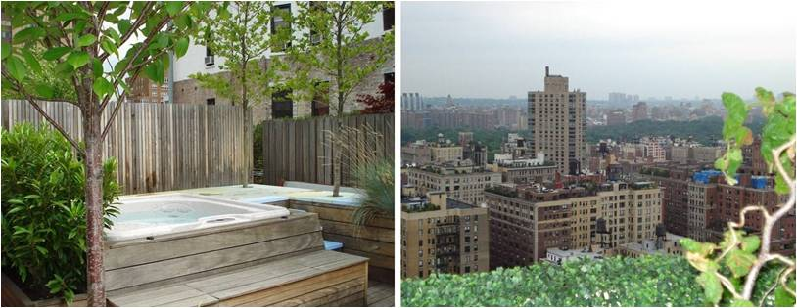
Hot tub time machine: Bubbles beckon on the roof of a classic brownstone on East 17th Street. At right, the view from a terrace on East 90th Street. (All photos: Nancy Lazarus)
A nearby penthouse on 72nd Street and Park Avenue offered a striking contrast, given its formal wrap-around terrace, sweeping view, and use of darker colors. Halsted Welles, the designer and owner of Halsted Welles Associates, described the setting as "Shangri-La." He said, "The aesthetic from the apartment inside was reflected on the terrace." His goal was "Simplicity, to make the walls the same as the floors so as not to end up with too many different elements." He noted that "Using black with white accents was important for the client, because that works best when lit at night for entertaining."
Friederike Biggs, the terrace owner, is an interior designer, and while she was extremely pleased with the end result, getting there was not so simple. "Some materials needed to be hoisted to the roof and retrofitted," she recalled. Among the terrace's numerous highlights were a stone fountain, brick walls, and arched passageways, multiple wrought iron tables, mirrors, and a weathervane. Shades of blue were visible throughout, including blue stone floors, hydrangeas, and blue and while ceramic planters.
The final stop on the tour was a penthouse terrace in a Philip Johnson-designed building on East 90th Street. The large and contemporary outdoor space was another Myers creation, and he described it as a "portable Zen garden with a modern, fun ambiance." A centerpiece was composed of stone and marble concrete pavers with crushed marble pebbles. Hornbeam trees and faux boxwood provided the greenery and red chairs added the accent color. The focal point was the unobstructed 180-degree view north that encompassed the East River, Yankee Stadium, and the George Washington Bridge.
Nancy Lazarus has covered media and travel for mediabistro.com's TVNewser, WebNewser, and PRNewser blogs. Learn more about her at www.NancyLMedia.com.

